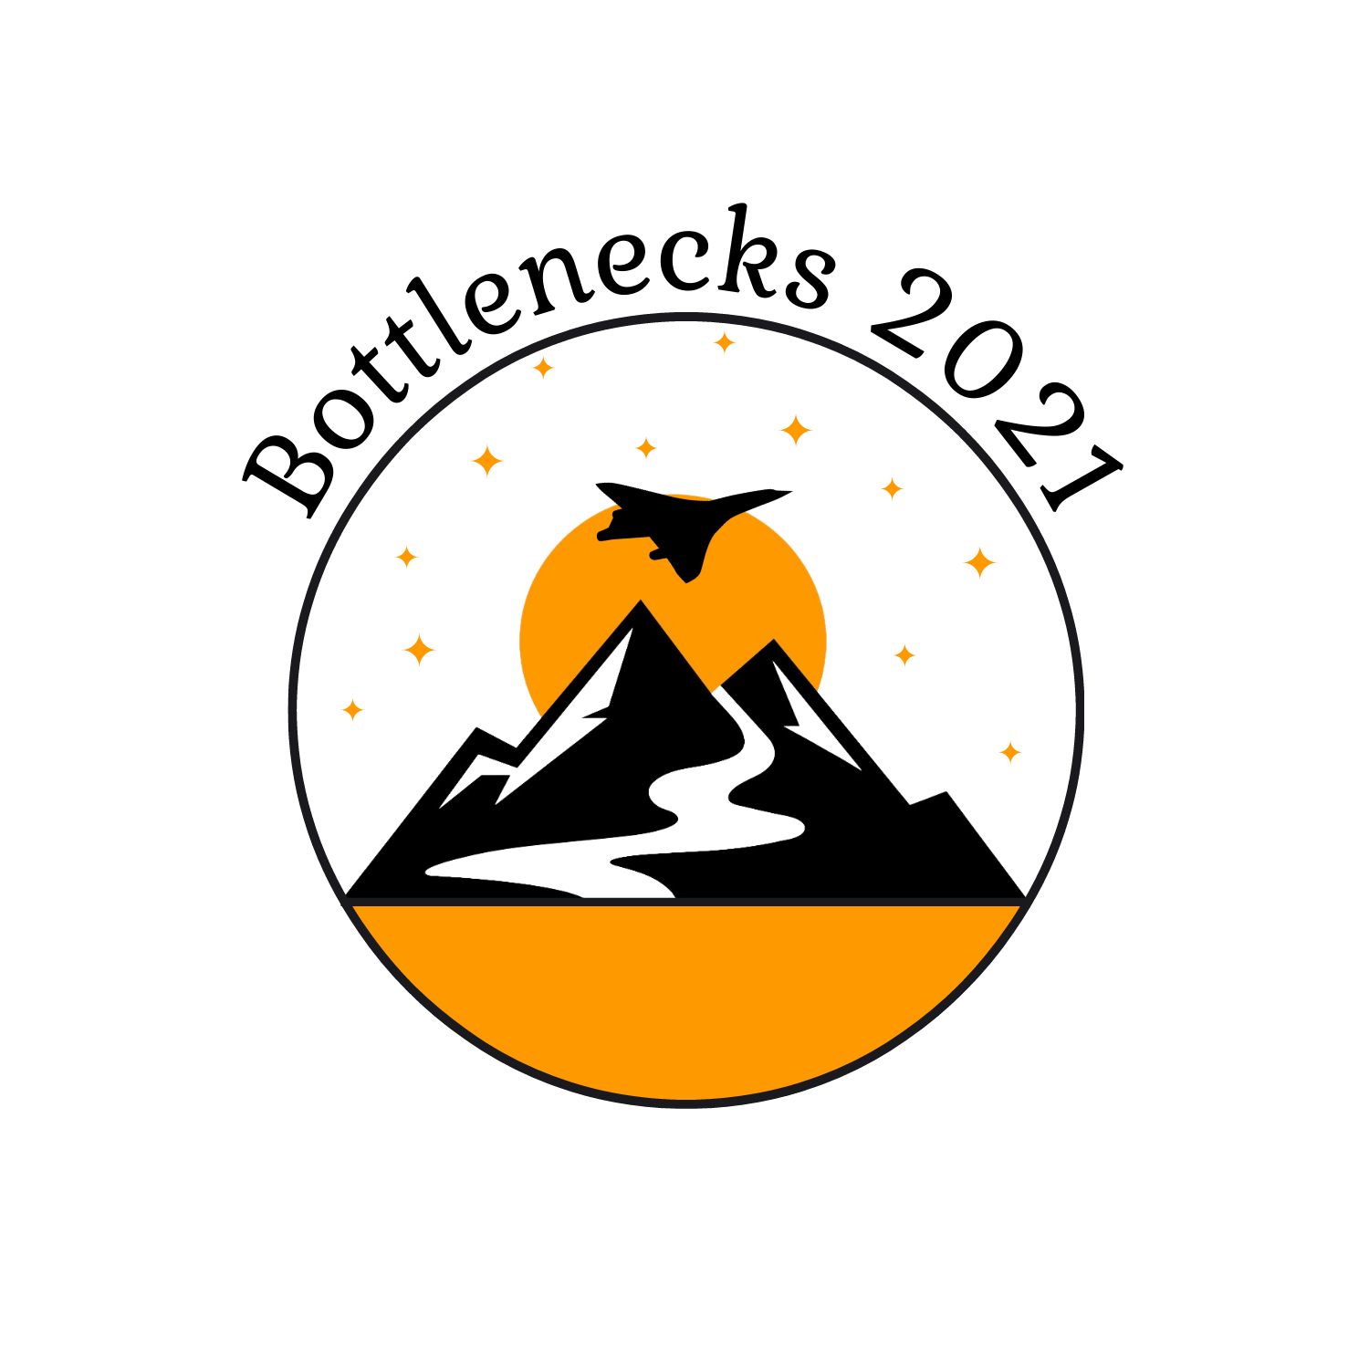
2021 BOTTLENECKS WORKSHOP SUMMARY & REVIEW

The 2021 Bottlenecks in Science and Technology Workshop brought together 33 researchers, funders, and institution designers at the Denver headquarters of supersonic aviation start-up Boom Supersonic to discuss bottlenecks to responsible scientific and technological progress and how to break them.

The workshop was co-organized by Leverage Research, Adam Marblestone, and José Luis Ricón and included:
- Presentations of bottleneck analyses across ten fields as diverse as energy production, metagenomic sequencing, psychology, and functional institutions,
- Keynotes from Peter Thiel, Patrick Collison, and Tyler Cowen, and
- Lightning talks covering topics such as building R&D in carbon capture and program design.
This document provides a summary of the purpose, objectives, key details, and outcomes from the 2021 Bottlenecks Workshop written by Leverage Research for external collaborators and supporters interested in learning about or from this initiative. It is currently a working draft rather than a final write-up as we expect to be able to announce further details on some specific outcomes and lessons from the workshop in the coming months.
Document Last Updated: August 23, 2021
Contents:
2021 BOTTLENECKS WORKSHOP SUMMARY & REVIEW
BACKGROUND: WHY BOTTLENECK ANALYSES?
WORKSHOP ORIGINS: THE BOTTLENECKS PILOT
ABOUT THE WORKSHOP
PURPOSE & OBJECTIVES
KEY FACTS AND FIGURES
AGENDA
PUBLICLY AVAILABLE CONTENT
WORKSHOP FEEDBACK: SURVEY DATA
OUTCOMES
PROGRESS ON THE WORKSHOP OBJECTIVES
IMPACT FROM THE WORKSHOP
SPECIAL THANKS

BACKGROUND: WHY BOTTLENECK ANALYSES?
Over the past two decades, we've heard narratives of extreme technological progress (singularity) and the extreme absence thereof (stagnation) and in today’s climate especially there is starting to be more of a public discussion about how to ensure scientific advances are made responsibly in a way that benefits society at large.

Scientific and technological progress is essential to human flourishing. However, if resources are not directed wisely we may fail to achieve progress or, in some cases, contribute to advances that are ultimately harmful. All of this means that in order to truly understand the current state of progress, take steps to push forward important advances, and ensure research is conducted responsibly and safely, we need a more intricate picture of what is happening on a field-by-field basis.

A bottleneck analysis is an attempt to identify the current social, institutional, and technical obstacles to further progress in different areas of science and technology. When successful, a bottleneck analysis provides a fine-grained understanding of the current state of a field and identifies leverage points where additional resources have the greatest chance of contributing to substantial progress.

By developing bottleneck analyses as a standard for understanding scientific progress, we can equip researchers, funders, and institution designers with the tools necessary to reliably spot areas where deliberate, safe progress can be made and to provide resources to achieve progress in those areas.

WORKSHOP ORIGINS: THE BOTTLENECKS PILOT
In order to test whether it is indeed possible to analyze a field effectively in this way, we identified 10 initial fields along with potential researchers to conduct bottlenecks analyses in.

Aging | Climate | Biosecurity | Telerobotics | Supersonic Aviation
Psychology | Neuropsychiatry | Positional Chemistry | Functional Institutions | Energy Production
A good bottleneck analysis considers the social, and institutional bottlenecks alongside technical ones. This requires some degree of generalist knowledge and experience in order to consider all three domains as well as the domain expertise to produce research that is of sufficient quality, depth, and concrete detail. We, therefore, opted for a breadth of initial fields across both natural and social sciences which seemed likely to have very different bottlenecks from one another and where we had connections with researchers with the relevant expertise.
These researchers were then asked to conduct an initial analysis which they could discuss with other researchers, funders, and program designers at a workshop to see whether the bottlenecks could be successfully analyzed, conveyed, and turned into valuable efforts on new or existing projects.

Summary of Selection Criteria:
- Anticipated social benefit and risk of unintended harms,  - Potential for progress in the field  - Established and nascent fields  - Natural and social sciences | - Likely to represent a mix of social, institutional, and technological bottlenecks.  - Available researchers with both field expertise and generalist research skillset required to analyze different types of bottlenecks
You can learn more about the origins of the workshop by listening to Leverage Research Executive Director Geoff Anders’ opening presentation from the workshop. Over the coming weeks, other talks from the workshop will be made available on the Bottlenecks YouTube Channel.

ABOUT THE WORKSHOP

PURPOSE & OBJECTIVES
The purpose of the workshop was to serve as a pilot for conducting bottleneck analyses and gauge feasibility and interest in such initiatives. The primary objectives of the workshop were to:
(1) PROGRESS IDENTIFYING BOTTLENECKS | (2) CREATION OF A NETWORK | (3) SUPPORT PROMISING PROJECTS | (4) CONCRETE NEXT STEPS
Objective Description:  Have researchers present bottleneck analyses that are roughly 80% complete in each of the 10 initial areas. This would allow us to learn about what such analyses should look like and get early feedback on the feasibility of the project. | Objective Description:  Create a network of funders, institution designers, and researchers who could contribute to bottlenecks research and beneficial projects. | Objective Description:  Identify and support promising projects in priority areas that address key bottlenecks identified by the analyses. | Objective Description:  Determine concrete next steps for the Bottlenecks Initiative after this pilot.

KEY FACTS AND FIGURES
DATES: | Friday, June 11 (welcome dinner) — Sunday, June 13 (departures on Monday, June 14)
LOCATIONS: | The workshop was hosted at the Denver HQ of supersonic aviation start-up Boom Supersonic. Accommodation & dinners were held at a nearby Hyatt Regency hotel.
SPEAKERS & PRESENTATIONS | - 3 keynote speeches by Peter Thiel, Patrick Collison, and Tyler Cowen  - 10 Bottleneck Analysis presentations  - 9 lightning talks
PARTICIPANTS: | The workshop had 33 final attendees including current and future researchers, funders, Program Managers, and Institution Designers

AGENDA
DAY ONE | DAY TWO
- Workshop Opening: Geoff Anders  - Bottleneck Analysis Presentations on:  - Supersonic Aviation  - Abundant Clean Energy  - Psychology  - Neuropsychiatry  - Biological Risk Reduction: Metagenomic Sequencing  - Climate Adaptation: Food Without Agriculture  - Day One Closing Keynote: Peter Thiel  Along with various group discussions and a tour of Boom Supersonic. | - Day Two Opening Keynote: Patrick Collison  - Bottleneck Analysis Presentations on:  - Functional Institutions  - Aging  - Positional Chemistry  - Telerobotics  - Lightning Talks on:  - Apprenticeship in Hard Tech  - Market Shaping  - Carbon Removal  - Institutional Diversification  - Innovation Pipelines  - Design & Creation of New Institutions  - Program Design  - Incentive Engineering  - Designing Incentive Interventions  - Case StudIes: From Analysis to Project  - It’s Time to Build (discussion of next steps)  - Keynote: Tyler Cowen  - Closing: Adam Marblestone & José Luis Ricón

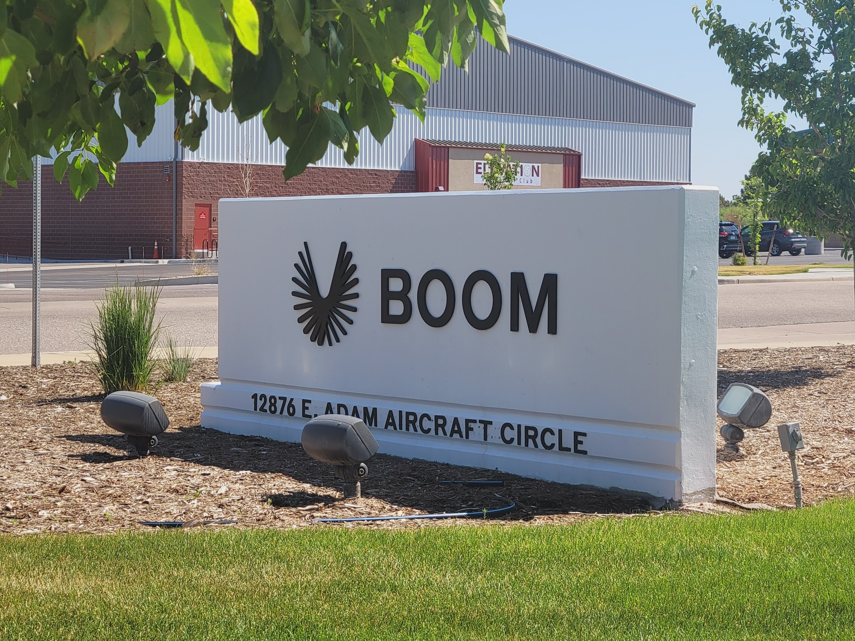 | 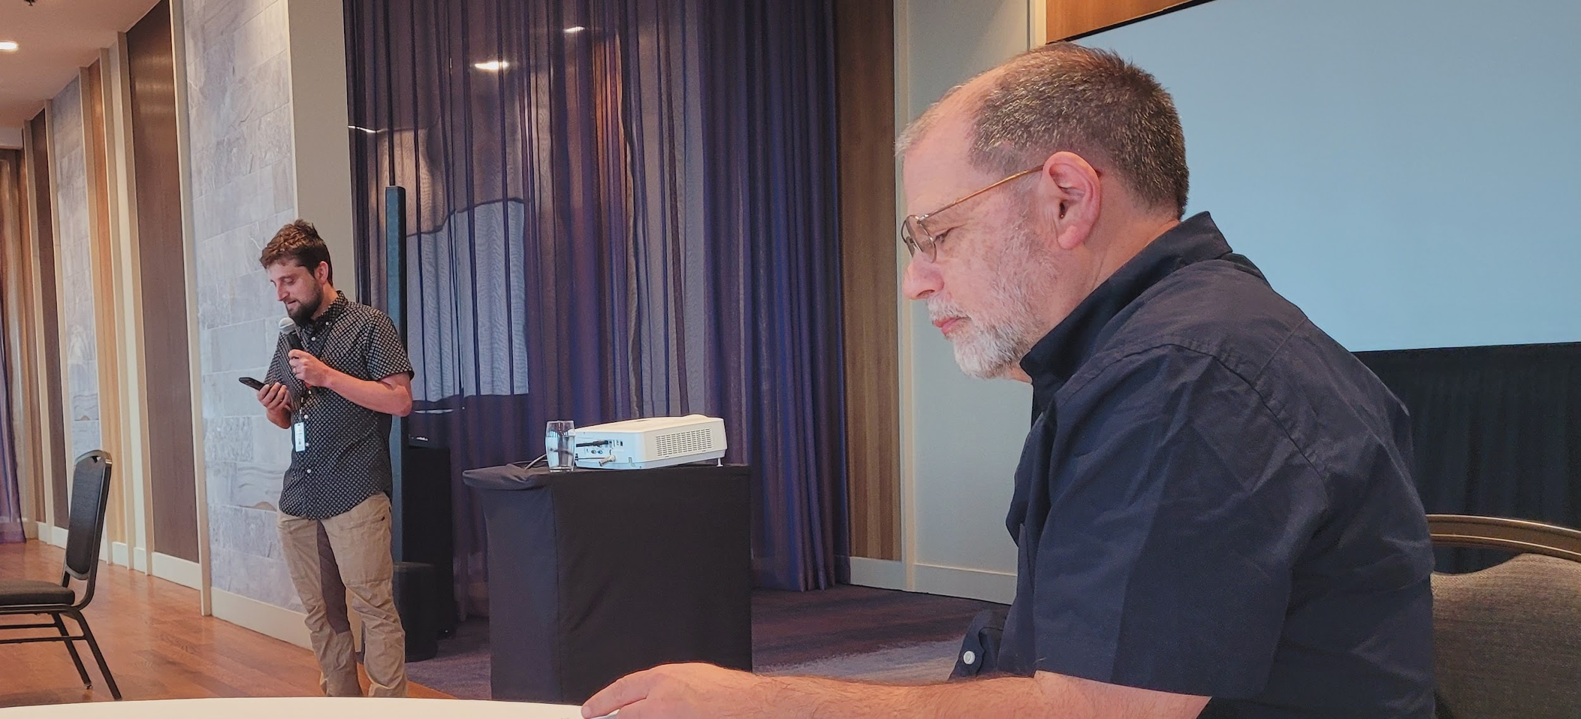
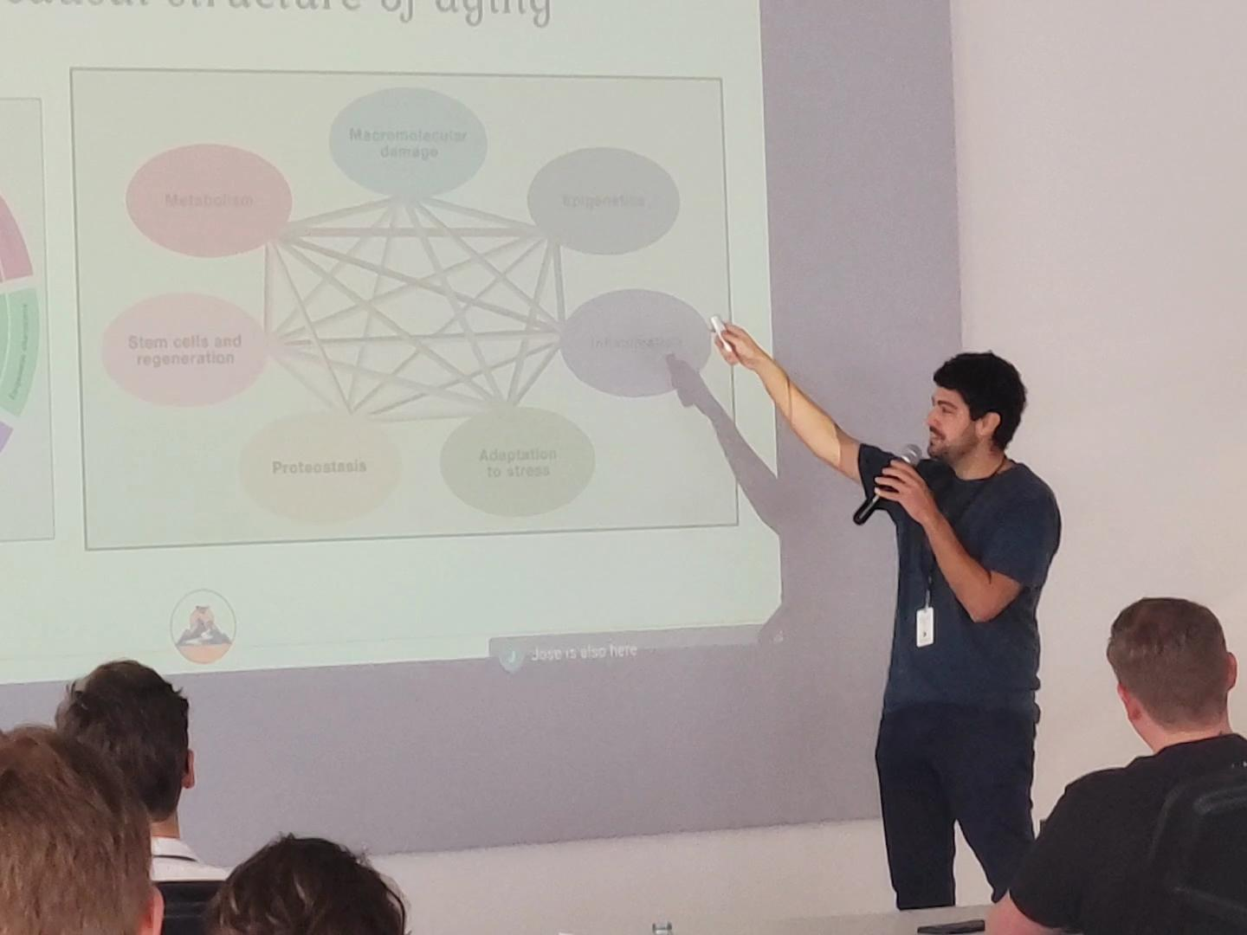 | 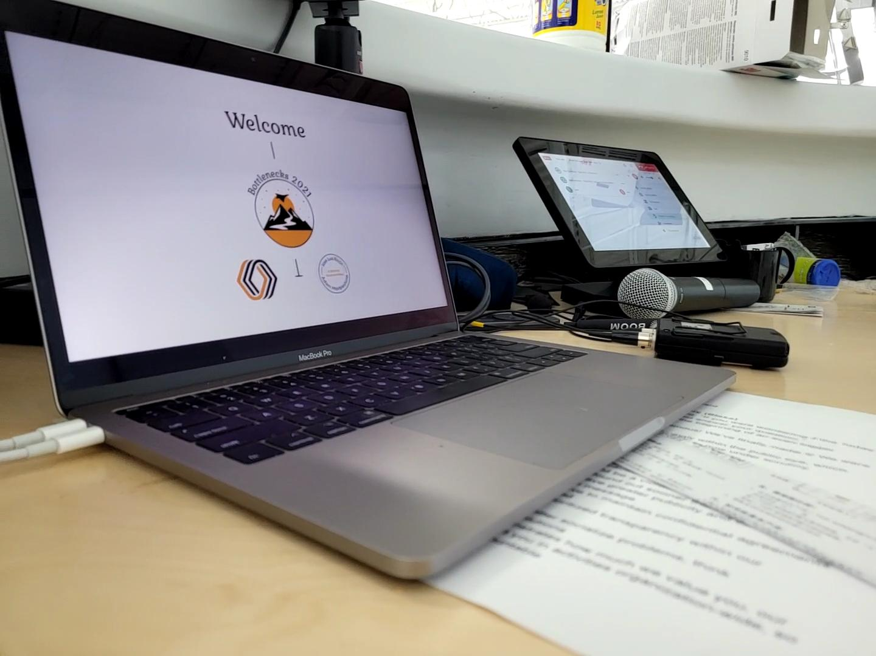

PUBLICLY AVAILABLE CONTENT
The event was held under Chatham House Rules to ensure that participants could speak candidly about the state of progress, and sometimes lack thereof, in their respective fields. However, some presenters have agreed to have lightly edited recordings of their talks made available and written public write-ups related to their work.

Lightly edited versions of presentation recordings which we have permission to share are available on the Bottlenecks YouTube Channel.

Eli Dourado, shared a piece on his area of bottlenecks research; Next Generation Geothermal, and Ben Reinhardt, wrote a piece about bottlenecks in telerobotics.

WORKSHOP FEEDBACK: SURVEY DATA
Just over half of the participants (51.72%) filled out a feedback survey sent out after the workshop. The workshop achieved a Net Promoter Score (NPS) of 87, 80% of participants said the workshop was a great use of their time, 71% said it was likely to lead to any meaningful improvements or changes to their plans, and all respondents were interested in being actively involved in various next steps.
How valuable was the workshop as a use of your time?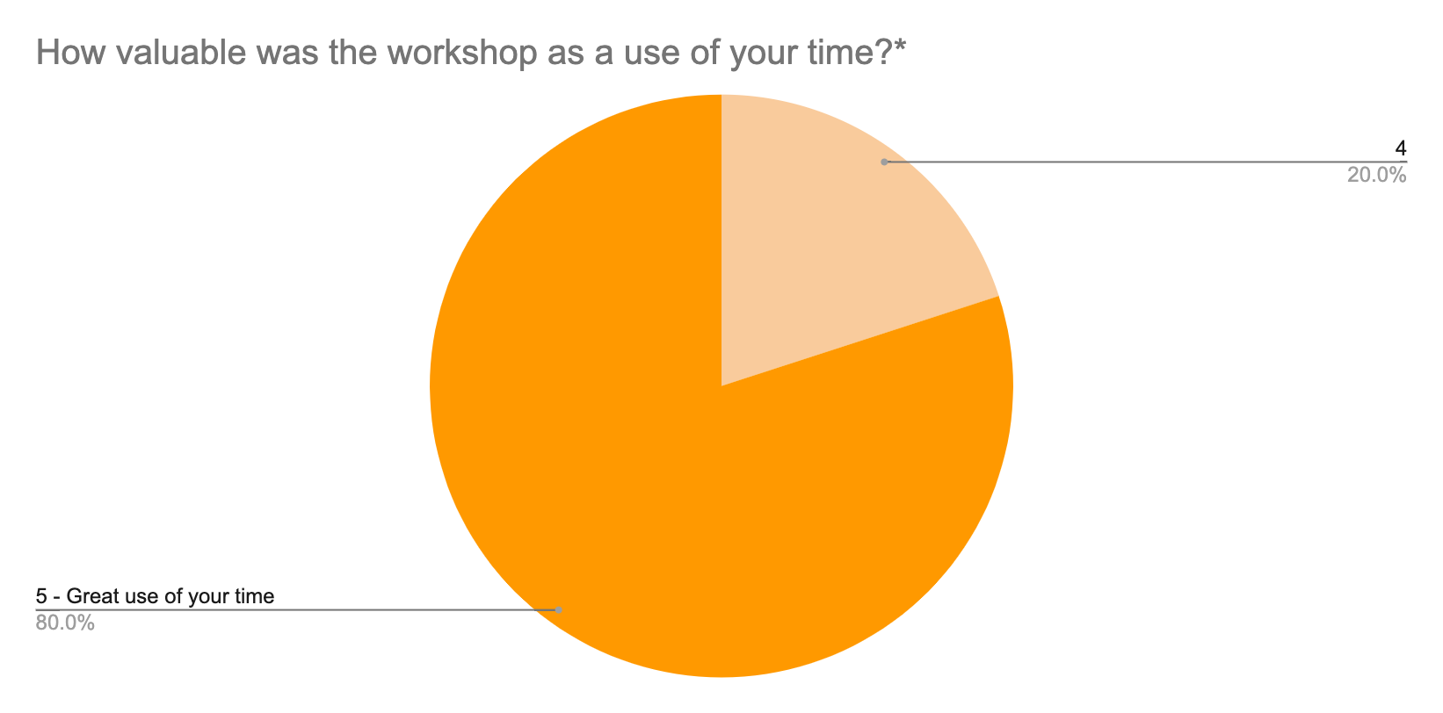
*1 - Poor use of your time, 3 = Indifferent (it seemed like neither an especially poor nor an especially good use of your time), 5 = Great use of your time.

Is the workshop likely to lead to any meaningful improvements or changes to your plans?
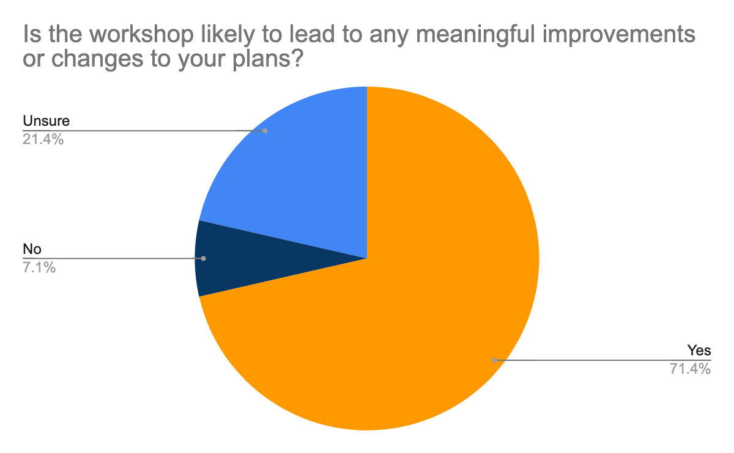

Net Promoter Score: 87
The Net Promoter Score (NPS) is a standard rating system commonly used to estimate satisfaction with products and events which asks How likely are you to recommend to a friend or colleague that they attend a similar workshop in the future? Answers are expressed from 0 - 10. "Promoters" are those who provide ratings of 9 or 10, "passives" or “neutral” provide ratings of 7 or 8, and "detractors" provide ratings of 6 or lower. The score is then calculated by subtracting the proportion of detractors from the proportion of promoters with the result typically expressed as an integer. Any score above 60 (on a scale of -100 to 100) is generally considered very good.

While we wouldn’t want to draw strong conclusions from this metric alone, especially given the small number of respondents, our experience with running events using this metric and articles on NPS scores make it a useful indicator along with other event data.

How likely are you to recommend to a friend or colleague that they attend a similar workshop in the future?
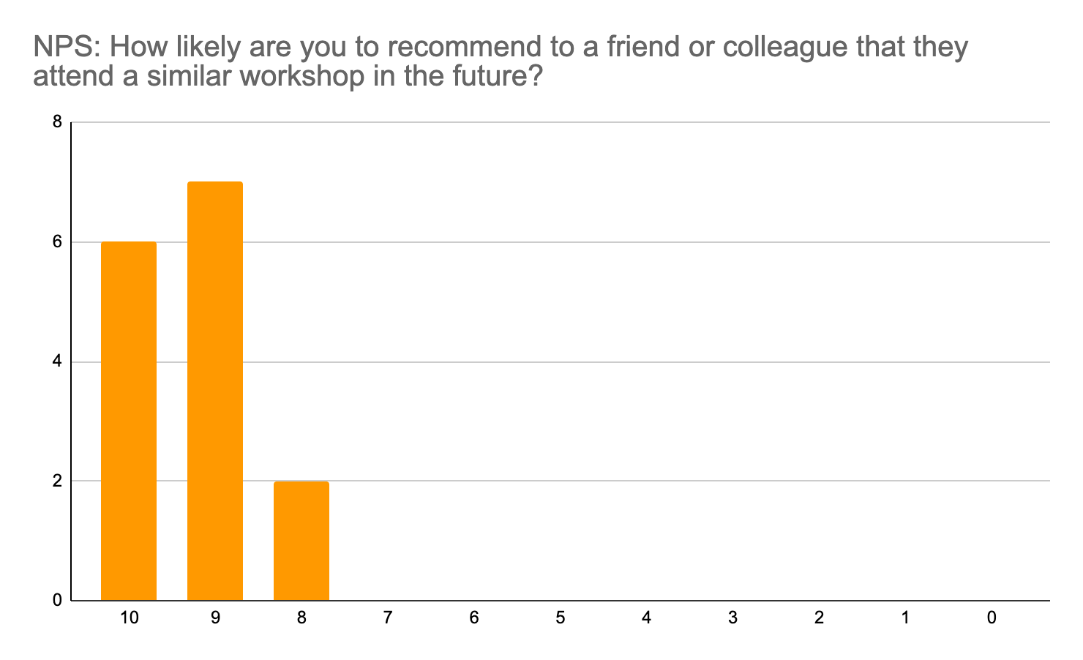
One area for improvement identified in the qualitative comments particularly was that the presentations were too long, especially given that attendees found the discussions to be especially valuable. This presents a challenge as we expect the focus on the presentations to have been important for creating a shared understanding of what a bottleneck analysis should look like. To address this, in our most recent workshop proposal we suggest a recorded video series of presentations in advance of the workshop so that common knowledge is created but outside of the workshop.

How did you feel about the length of time spent on different activities at the workshop?

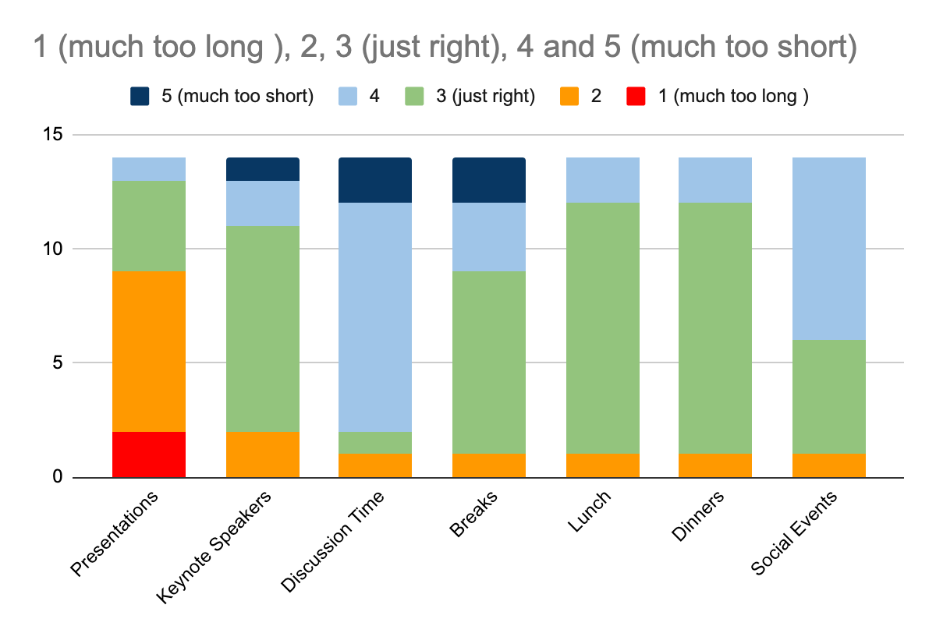

OUTCOMES

PROGRESS ON THE WORKSHOP OBJECTIVES
(1) PROGRESS IDENTIFYING BOTTLENECKS
Progress:
Researchers presented bottleneck analyses that were roughly 80% complete in each of the 10 initial areas.

We are in discussions with several researchers about writing full analysis papers to be published in Q1, 2022

(2) CREATION OF A NETWORK
Progress:
Several attendees mentioned the connections and new partnerships as key highlights of the workshop.
All survey respondents were interested in being actively involved in one of the potential next steps such as writing analyses, running future workshops, or joining discussion groups.

(3) SUPPORT PROMISING PROJECTS
Progress:
As a result of this workshop, Leverage Research and Protocol Labs plan to collaborate to organize an event series aimed at building effective research programs. [Read the initial proposal.]

While we cannot make details public at this time, there are currently three potential projects that were created through or bolstered by the workshop which we believe will be beneficial to humanity’s long-term flourishing.

(4) CONCRETE NEXT STEPS
Progress:
We currently have concrete next steps for the Bottlenecks Initiative including:
- Write-ups of full bottleneck analyses
- A new event series designed to generate and share knowledge on successful research and research management. [Read the initial proposal.]
- Plans for a 2022 Bottlenecks Workshop to review progress on bottlenecks from the first workshop and expand to analyze new fields.

We will add additional updates here as they are announced.

IMPACT FROM THE WORKSHOP
Impetus Grants
The idea and initial funding for Impetus Grants, which has received more than $20M in donations for “Fast Grant”-style funding for longevity, arose from a conversation at the workshop.

Activate’s Carbon Dioxide Removal (CDR) Imperative
This new Carbon Dioxide removal initiative between Stripe and Carbon180 initiative was catalyzed by people who met at the workshop.

Bottlenecks London
The success of the workshop inspired Prima Materia to run an informal “BottlenecksX” style event in London to start conversations about breaking bottlenecks in science and technology in Europe.

SPECIAL THANKS
We want to say a special thank you to our co-organizers Adam and Jose, along with the key contributors without whom the workshop would not have been possible:

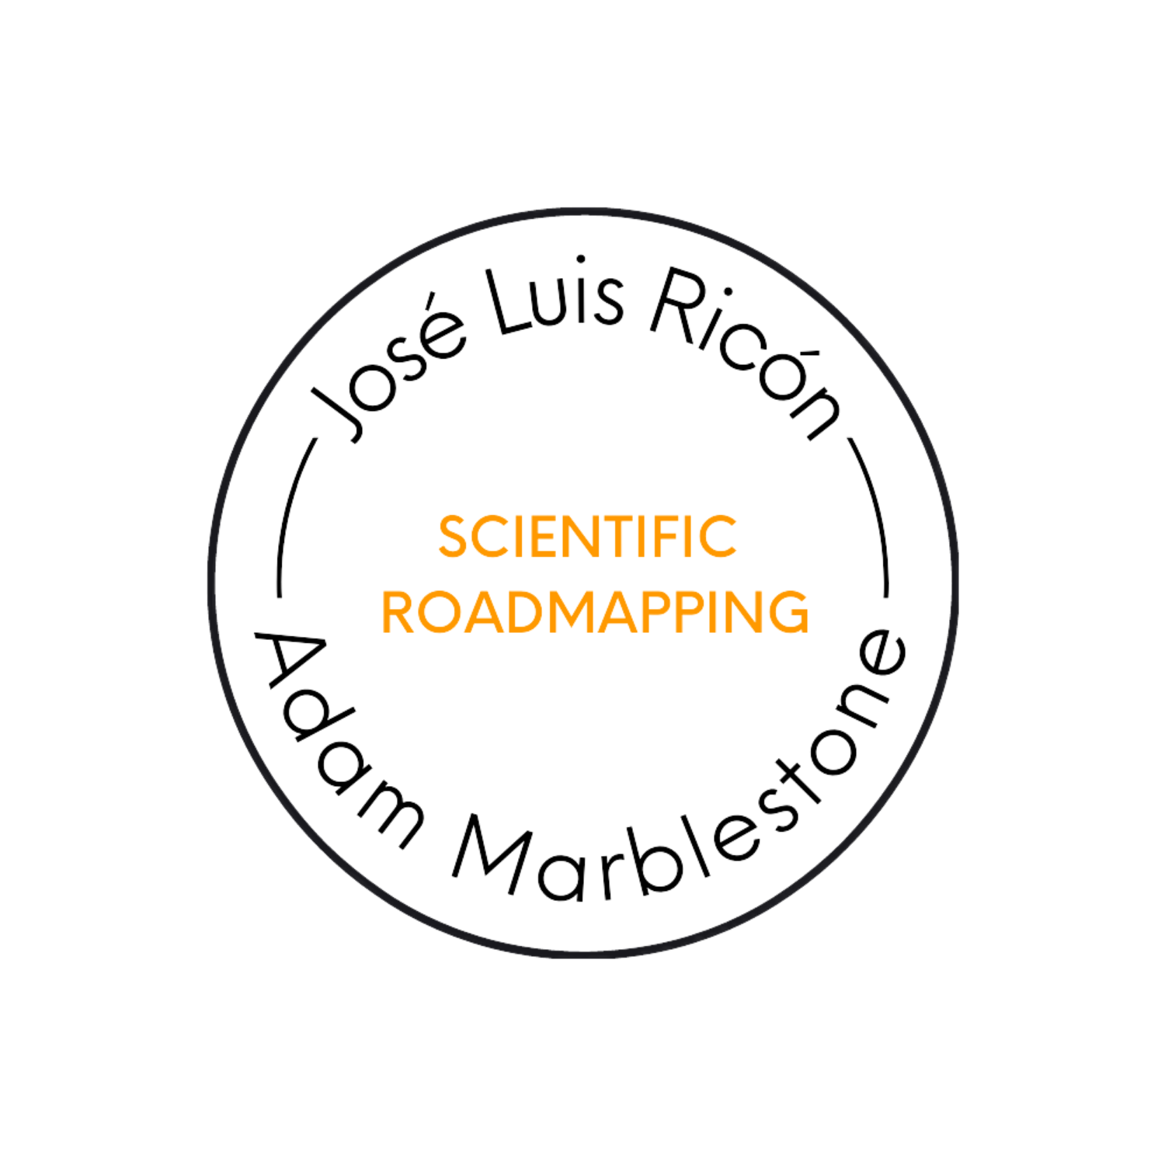
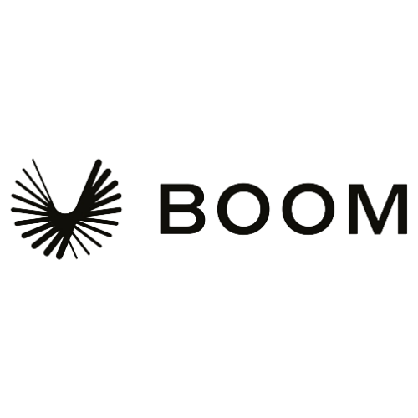 | 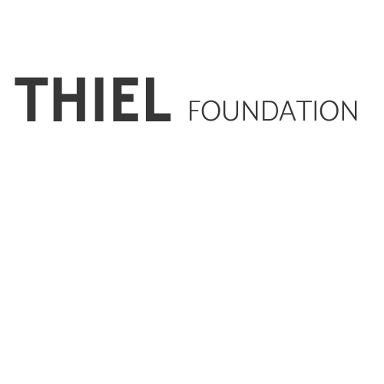 | 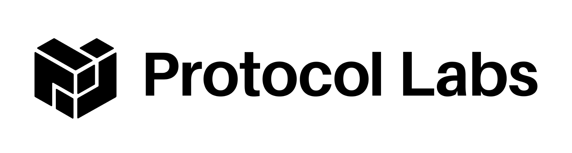 | 

